

**VR Modeling and World Building Hub**

**Team Project 1---Sun Cycle**



T1,2023

redback operations

Written By: JIAHAO FENG

**Contents**

**Game information** 1

Game Name 1

Game System 1

Target groups 1

Target platform (hardware required) 1

release date 1

Game Logo 2

**Game Overview** 2

Game Objective 2

Background Story 2

The core idea of the game 3

**Gameplay** 3

core gameplay-- Cycling Against Friends/Ghosts" 3

Game system analysis 4

**Gaming Hardware** 4

Development tool and software 4

Technical Difficulties 4

Recommended equipment 5

**Game audio-visual style and experience analysis** 6

Analysis of Gaming Experience 6

Analysis of Audio Styles 8

**Reliability and Availability Requirements** 8

Stable Hardware Equipment: 8

Stable Software System: 8

User-Friendly Human-Computer Interaction: 9

Game Security: 9

**Profitability analysis** 10

Profit Model 10

User retention rate and payment rate 11

# **Game information**

## Game Name

Sun Cycle

## Game System

Windows， MACOS,

## Target groups

Fitness enthusiasts: Sun Cycle can provide them with new challenges and stimulation, allowing them to enjoy more fun while maintaining their fitness.

Busy workers: Many people are too busy with workand do not have time to go to the gym, so Sun Cycle can provide them with more convenient and flexible time choices.

Gamers: For those who enjoy playing games, Sun Cycle can combine fitness and gaming, allowing them to exercise while playing games.

People who want to lose weight: For those who want to lose weight or control their weight, Sun Cycle can provide an interesting way to exercise, making it easier for them to stick to it.

## Target platform (hardware required)

PC, VR facilities

## release date

2024 OCT

## Game Logo



# **Game Overview**

## Game Objective

The aim of Project Sun Cycle is to create an entertaining and immersive virtual reality game. Players will wear a head-mounted display and use handheld controllers, or a stationary bike stand to simulate real bike movements and play the game in a virtual reality world. The game encourages people to exercise while playing, and in this game, players need to navigate a post-apocalyptic tribal environment using a bike and complete quests such as delivering supplies between tribes on a hover skater-bike. The game provides an opportunity for players to explore and travel through the environment, with the goal of motivating individuals to exercise more through the enjoyment of video gaming. Players can adjust the bike's speed to achieve exercise goals and collect and use different props to enhance their game experience. The game also provides various health management features such as recording and analyzing player's exercise data, monitoring heart rate and calories burned to help players achieve their health goals. In addition, the game will offer a user-friendly interface, stable hardware and software systems, and security measures that highly prioritize game safety to ensure a safe and reliable game experience for players while enjoying the fun of the game.

## Background Story

The story background of Project Sun Cycle is set in a post-apocalyptic world where human civilization has been destroyed, and the remaining humans survive in tribes. Players need to play as a member of a tribe, maneuvering a bicycle to complete various tasks to obtain the resources and supplies necessary for the tribe's survival. Players can exercise and improve their health by exploring this virtual reality world.

## The core idea of the game

The core idea of the game is to combine virtual reality and physical exercise, using virtual reality technology to encourage players to participate more actively in physical activity and provide a fun and effective way to exercise. Players use a bicycle to play and explore in the virtual world, while providing an attractive post-apocalyptic story background and tasks. The design philosophy of the game is to combine entertainment and health, allowing players to achieve the goal of exercising through the fun of the game. At the same time, the game also provides a variety of health management functions, such as monitoring heart rate and calorie burning, to help players achieve their health goals. Therefore, the core idea of the game is to integrate entertainment and health, providing players with a new exercise experience.

# **Gameplay**

## core gameplay-- Cycling Against Friends/Ghosts"

One of the core gameplay features of Sun Cycle is "Cycling Against Friends/Ghosts". Players can invite friends or match with other players to compete in a two-player mode.

In the two-player mode, players race against each other on a virtual road. Players can control their virtual bike using pedals, handlebars, and game controllers, and control their speed through acceleration and deceleration. During the game, players need to avoid obstacles on the road, collect game props, and compete with opponents to reach the finish line within the designated time.

In our team's future development plan, we plan to add battle props to the two-player mode. Players can use various game props to interfere with opponents, such as throwing bombs and placing obstacles. In addition, players can also obtain extra game scores by completing small tasks and challenges in the game to increase their chances of winning.

Cycling Against Friends/Ghosts mode adds social and interactive features to the game, allowing players to play games and exercise with other players, increasing the fun and challenge of the game.

## Game system analysis

Hardware: Includes VR headsets, controllers, and cycling machines. VR headsets provide a virtual reality environment, while controllers and cycling machines simulate the control operations during cycling.

Software: Includes game engine - Unity 3D, artificial intelligence, network communication, and other technologies. The game engine can implement the physical simulation, rendering, and interaction functions of the game; artificial intelligence can provide intelligent operations for NPCs; network communication can realize the interaction and data transmission between players.

Database system: Used to store players' personal information, game records, rankings, and other data.

The advantages of the game system are that it can provide players with a more realistic and immersive gaming experience through virtual reality technology. At the same time, players can exercise in the game through the cycling machine. However, the hardware and software systems of the game system require relatively high technical thresholds and costs, and also require a certain amount of space to support the use of cycling machines and other equipment.

# **Gaming Hardware**

## Development tool and software

Game Engine：unity 3D (2020.3.37f1)

Asset building software：3DMAX ,Blenders, Maya

File and Project share platform: GitHub, Teams

Development device： Oculus Quest2，HTC VIVE Pro

## Technical Difficulties

1. Interactive concept based on VR

2. VR-based UI display

3. The motion mechanism of VR interaction

4. Optimize rendering

5. 3D modeling and rigging

7. 3D sound effects and ambient sound feedback

## Recommended equipment

**·HTC VIVE Pro--- Headset Specs(VR)**

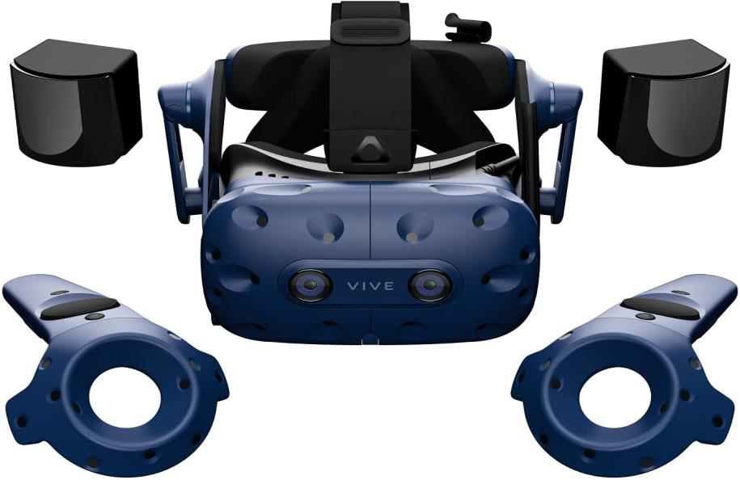

Screen: Dual AMOLED 3.5" diagonal

Resolution: 1440 x 1600 pixels per eye (2880 x 1600 pixels combined)

Refresh rate: 90 Hz Field of

view: 110 degrees

Audio: Hi-Res certificate headset

Hi-Res certificate headphones (removable)

High impedance headphones support

Input Integrated microphones

VIVE Pro Professional Edition provides a uniquely immersive experience. It uses precise tracking technology, bright and full colors, and ultra-realistic sound effects to create a virtual world. It allows users to reach where they can imagine in an instant. With the top VR display technology, VIVE Pro Professional Edition makes virtual reality extremely real.

·HTC VIVE Pro--- Controller Specs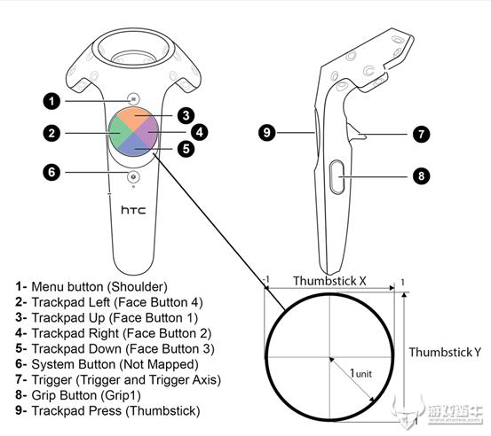

Sensors： Steam VR Tracking 2.0

Input： Multifunction trackpad

Grip buttons

dual-stage trigger

System button

Menu button

Use per charge： Approx. 6 hours

Connections： Micro-USB charging port

Tracked Area Requirements

Standing /seated: No min. space requirements

Room-scale: Up to 10m x 10m using four Steam VR Base Station 2.0.

The included two base stations support up to 5m x 5m.

# **Game audio-visual style and experience analysis**

## Analysis of Gaming Experience

One of the core gameplay features of Sun Cycle is "Cycling Against Friends/Ghosts", which combines real cycling with virtual racing. Players can compete against other players while enjoying the excitement and immersive experience of the virtual reality environment.

Advantages:

Realism: With support from VR headsets, cycling machines, and VR technology, players can get a more realistic cycling experience in the game, especially when competing against other players. This can help players exercise better while providing a more enjoyable gaming experience.

Challenge: The two-player battle mode requires players to concentrate, react quickly, formulate strategies and make decisions, providing players with higher challenges and excitement. At the same time, players can also increase the game difficulty and fun by completing small tasks and challenges in the game.

Sociality: Sun Cycle's "Cycling Against Friends/Ghosts" mode increases the game's social and interactive aspects, allowing players to play games and exercise with other players. This can increase the game's fun and challenges.

Disadvantages:

High cost: To get a better gaming experience, it is necessary to purchase hardware equipment such as VR headsets and cycling machines, which will increase the cost of the game. Especially the cycling machine, the player's experience will be greatly discounted if it is lacking.

High technical threshold: Devices such as cycling machines require some technical support and settings, and not all players are capable of using and adjusting these devices.

High space requirements: Devices such as cycling machines require a certain amount of space for installation and use, which can restrict some users' use.

## Analysis of Audio Styles

When players play the game, there are three types of music available for players to choose from.

EDM: Since Sun Cycle is a virtual reality fitness game, using EDM music style can increase the game's vitality and excitement. This type of music usually contains strong rhythms, repetitive melodies, and modern electronic sound effects. This music can motivate players to increase their exercise intensity and power, making them more engaged and focused on the exercise process.

Sports Rock: Sports rock music style combines rock and sports elements, which can bring a sense of power and vitality to the Sun Cycle game. This type of music usually has strong guitars and drums, as well as inspiring lyrics and melodies. Rock music can help players get rid of negative emotions, enhance self-awareness and motivation, relieve anxiety and stress, make the exercise process more pleasant and inspiring, and inspire players' fighting spirit and determination, making them more focused on exercise and persevering.

Environmental Atmosphere: Environmental atmosphere music can create a natural and relaxed atmosphere. This type of music usually contains natural sounds, such as wind and bird sounds, as well as pleasing harmonies and gentle melodies. When players just want to ride their bikes and explore the map, this music can help players relax better.

# **Reliability and Availability Requirements**

## Stable Hardware Equipment:

The VR bike game requires stable hardware equipment, such as a head-mounted display, hand-held controllers, and a bike bracket. One of our features is the ability to play the game using a bike bracket. These devices need to be able to run stably and maintain good connectivity and response speed during the game to ensure the stability and smoothness of the game.

## Stable Software System:

The VR bike game requires a stable system to support game operation, including game engines, virtual reality technology, and game data storage, etc. These systems need to ensure stability and compatibility and be able to handle various abnormal situations in a timely manner to ensure game reliability. Therefore, during software development, sufficient testing needs to be done to ensure software stability. Types of testing include unit testing, integration testing, system testing, etc. These tests can discover problems in the software and solve them in a timely manner, thereby improving software quality and stability. At the same time, the VR bike game needs to accurately record and reflect the player's motion data, such as speed, distance, heart rate, etc., and these data need to be accurately displayed on the game interface.

## User-Friendly Human-Computer Interaction:

Sun Cycle needs to have a user-friendly human-computer interaction interface, such as clear and concise game operation guides, reasonable game prompts, and easy-to-understand game goals, etc. These interface designs need to conform to user habits and needs. At the same time, we need to consider users' cognition and psychological models in interface design, such as using icons, symbols, and interface layouts similar to real objects. This will help users easily get started with the game and enjoy the fun it brings.

## Game Security:

As a fitness game, safety is the most important point for Sun Cycle. During the design process, we need to ensure the player's safety during the game and avoid players being injured or exposed to unnecessary risks. We need to remind players to reduce exercise intensity when their heart rate is too high. At the same time, the game needs to comply with privacy laws and regulations. When we need to collect, store, and use user information, we must obtain the user's consent and take corresponding security measures to protect the user's personal information, such as using encryption technology to ensure the security of user data.

Generally speaking, Sun cycle need to have high reliability and high availability to ensure the stability, smoothness, safety and user-friendliness of the game process.

# **Profitability analysis**

VR fitness games, as an emerging game type, are becoming increasingly popular. The profitability analysis of the game can help the company further understand the profit model, profit sources, user retention rate, user payment rate, and other aspects of VR game Sun Cycle. This part can provide a reference for the company's future development and optimization of game profitability.

## Profit Model

Paid Download: The game can provide paid downloads on major gaming platforms, and users need to pay a certain fee to download the game. This model is a relatively stable profit model because players must pay to enter the game. Paid downloads can attract more users through the evaluation, promotion, and word-of-mouth of the game. However, this method will also make users have higher requirements for our game. At the same time, when formulating pricing strategies, we need to consider factors such as game quality, user demand, and market competition. The pricing should not be too high, otherwise, it may affect sales volume and user satisfaction. It should not be too low, otherwise, it may affect the game's brand image and profitability.

Free Download: Users can download our game for free, but we will generate revenue by placing ads in the game, such as brand promotion and cooperative advertising. Advertising revenue can bring certain revenue to the game, but we need to pay attention to the content and frequency of advertising to not affect the user experience and fluency. At the same time, the location of advertising has a significant impact on advertising revenue, and we need to choose the most suitable advertising location according to the game's interface and user operation process. Generally, the advertising position should not affect the game experience while attracting the user's attention.

Virtual Goods Sales: We can add virtual props in the game for players to purchase, such as clothing, accessories, unique bicycle models, etc. Virtual goods sales are a more flexible profit model that can bring more stable revenue to the game. At the same time, the sale of virtual goods can also provide a better user experience and attract user consumption. However, the key to the success of the virtual goods sales profit model depends on the game player's participation and loyalty. We need to continuously improve the game's experience and fun, strengthen community interaction, and thereby increase user participation and loyalty. At the same time, the design and sales strategy of virtual goods also need to be continuously improved and optimized to attract more users to purchase.

## User retention rate and payment rate

User retention rate and payment rate are two key indicators that measure the game's profitability.

User Retention Rate: The user retention rate refers to the percentage of game players who continue to stay in the game during a certain period. The retention rate directly affects the number of active users of the game and the game's profitability. Generally speaking, if a game has a high user retention rate, it means that the game's player experience and fun are good, and players like to play this game, which may encourage them to spend more time and money playing.

Payment Rate: The payment rate refers to the percentage of players in the game who are willing to purchase virtual items or game content. This is an important profitability indicator because the higher the payment rate, the higher the game's revenue. The payment rate is usually affected by the design of virtual items or game content, pricing strategies, and promotional activities. If virtual items or game content are attractive enough and the price is reasonable, the payment rate may increase.

The key factors to improve user retention and payment rate include:

Providing high-quality game content and experience: We need to constantly add new content, such as new maps and activity rewards, in subsequent updates. At the same time, we can add new achievement rewards to attract players to complete, increasing their sense of achievement. In addition, ensuring game balance and stability is also crucial, as it can make players feel fair and confident, and encourage them to continue playing.

Designing unique and rare virtual items to attract players to purchase and increase payment rate. This can encourage players to spend more time and money in the game because they want to own unique items. We can motivate players to purchase virtual items through limited-time promotions, special rewards, etc. However, it is important to ensure that items do not affect game fairness.

Analyzing and providing feedback on user data: We need to actively respond to player feedback and constantly optimize game content and functionality according to player feedback and needs, which can improve user retention and payment rate. In addition, analyzing user data can also allow developers to better understand user behavior and preferences, thus better satisfying their needs and expectations.

In summary, user retention and payment rate are two important indicators for measuring game profitability. Developers need to improve these two indicators by enhancing game experience and interest, designing unique virtual items and pricing strategies, and continuously optimizing game content and functionality, thereby increasing the game's profitability.